**Paper**

Kt = 0.033 ; ke = 0.075 ; ke/kt =aprox 2

Less prominent removal of ligand-induced EpoR removal (ke) (vs ligand independent EpoR removal (kt) ) from the plasma membrane

**Me**

Kt = 197.801936 ; ke = 230.709304 ; ke/kt =approx. 1

# Second

Epo is rapidly

depleted from the medium by endocytosis-mediated

uptake and subsequent degradation

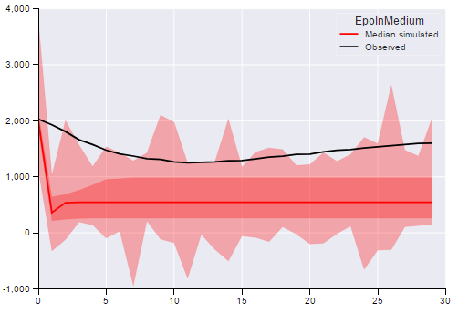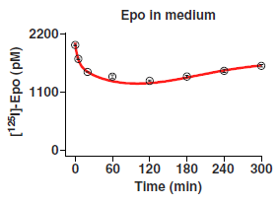

# Third

To assess dynamic properties that

determine conversion of ligand binding into

receptor activation, we derived from the model

(13) the time-dependent half-life of species in a

specific subcompartment (fig. S7 and SOM text).

This analysis suggested that **ligand-induced endocytosis**

**has an important role in shaping the earlyresponse**

**kinetics of EpoR activation**